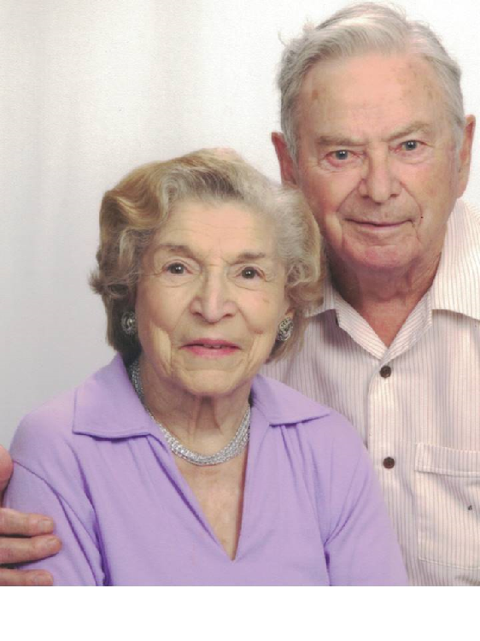
Name: | Victor Joseph Renard Adopting father of Robert-13170^{1–4}
Sex: | Male
Father: | John Renard-13157 1887-1948
Mother: | Rose Seiler-13158 1886-1965
Individual Facts
Birth | 22 Apr 1922 | Green Bay, Brown County, Wisconsin, United States (North America)^{2–3}
Residence | 1935 (about age 13) | Green Bay, Brown County, Wisconsin, United States (North America)³
Residence | 6 Apr 1940 (age 17) | Green Bay, Brown County, Wisconsin, United States (North America)³
Residence | 1941 (about age 19) | Green Bay, Brown County, Wisconsin, United States (North America)³
Residence | 1942 (about age 20) | Green Bay, Brown County, Wisconsin, United States (North America)³
Military | 11 Mar 1942 (age 19) | Victor enlisted for three years as an Apprentice Seaman. Source: discharge certificate³
Historical fact | 28 Feb 1943 (age 20) | See note; County of Philadelphia, Pennsylvania, United States (North America)³
Military | aft 1943 (after about age 21) | See note³
Military | 14 Feb 1946 (age 23) | Honorable Discharge as Seaman First Class. Source: Discharge certificate from the U.S. Coast Guard³
Historical fact | 29 May 1946 (age 24) | See note; Green Bay, Brown County, Wisconsin, United States (North America)³
Historical fact | 12 Dec 1948 (age 26) | See note³
Historical fact | 13 Dec 1948 (age 26) | See note; Green Bay, Brown County, Wisconsin, United States (North America)³
Residence | 1949 (about age 27) | Green Bay, Brown County, Wisconsin, United States (North America)³
Residence | 1951 (about age 29) | Renard, Victor J. (Delores), employee of Morley-Murphy. Home: 1250 Vanderbraak; Green Bay, Brown County, Wisconsin, United States (North America)³
Historical fact | 2 Dec 1952 (age 30) | See note; Green Bay, Brown County, Wisconsin, United States (North America)³
Residence | 1953 (about age 31) | Green Bay, Brown County, Wisconsin, United States (North America)³
Historical fact | 28 Mar 1960 (age 37) | Green Bay, Brown County, Wisconsin, United States (North America)³
Residence | 1981 (about age 59) | Little Suamico, Oconto County, Wisconsin, United States (North America)³
Residence | 1996 (about age 74) | Suamico, Brown County, Wisconsin, United States (North America)³
Residence | 1998–2002 (about age 76–about 80) | Suamico, Brown County, Wisconsin, United States (North America)³
Occupation | bef 2016 (before about age 94) | Part owner/operator of Renard Machine Company⁵
Death | 12 Apr 2016 (age 93) | Green Bay, Brown County, Wisconsin, United States (North America)²
Burial | aft 12 Apr 2016 (after age 93) | Unknown cemetery (several exist in the area), Green Bay, Brown County, Wisconsin, United States (North America)^{2–4,6}
Funeral | 18 Apr 2016 (age 93) | Green Bay, Brown County, Wisconsin, United States (North America)³
Marriages/Children
1. Dorothy Myrtle Dixon Natural mother of Robert Wayne-13140 1922-2018
Marriage | 28 Dec 1953 (age 31) | First Presbyterian Church, Green Bay, Brown County, Wisconsin, United States (North America)³
Children | Larry Kenneth Renard Adopted-13148 1946-2007
 | Robert Wayne Renard (bio:Pagel) Adopted by Victor-13147 1948-
 | James Victor Renard-13160 1960-1975
2. Dolores Marie Fahey-13159 1923-2008
Marriage | 1 Jun 1946 (age 24) | Green Bay, Brown County, Wisconsin, United States (North America)³
Notes
Notes: Victor Joseph Renard Adopting father of Robert-13170
Birth (22 April 1922): He was the son of John Renard (April 1887- 14 Dec 1948) and Rose Seiler (1886-21 May 1965). Family living at 1202 Willow St. Source: State of Wisconsin Birth Record
Residence (1935): Source: 1940 United States Federal Census
Residence (6 April 1940): John, 53, working in emergency in a W.P.A. project; Rose, 52; Chester, 27, an apprentice in auto repairs; Marie, 23; Victor, 17, a student; David, 14. They are renting at 825 Harvey. Source: 1940 United States Federal Census
Residence (1941): Renard, John J., a cement worker, his wife Rose, their children Marie, Chester (in the U.S. Navy) and Victor are listed in the Green Bay, De Pere, Allouez, Preble City Directory for 1941
Residence (1942): Victor Renard is listed in the East High School yearbook as "Men of East in the Service."
Historical fact (28 February 1943): Victor Renard, 20, a Coast Guardsman, of 3d & Spruce st, was treated at Methodist Hospital due to an injury in a Trolley Derailment.
Source: The Philadelphia Inquirer, Sunday, 28 Feb 1943, page 18
Military (after 1943): Certificate of Military Service
For Honorable Service in the United States Coast Guard and for Outstanding service and Loyalty to the United States of America
Historical fact (29 May 1946): Marriage License for Victor J. Renard of 1027 Berner street and Dolores Marie Fahey of 1027 Berner street.
Marriage (1 June 1946): Victor J. Renard, a commercial fisherman, and son of John Renard and Rose Seiler, weds Dolores Marie Fahey, a typist, at St. Peter and Paul Church.
Historical fact (12 December 1948): Death of his Father
John Renard was employed by L.J. Reis, contractor, working at Hillside Transit Garage on Lincoln street when he fell off a ladder; the injuries were fatal
Historical fact (13 December 1948): Death Reported for his father
John Renard, 63, 1027 Berner street, died in a local hospital early Sunday morning from injuries sustained when he fell off a ladder Friday afternoon.
Source: Green Bay Press-Gazette, Mon. 13 Dec 1948, p. 34
Residence (1949): Renard, Victor J (Dolores), employed at Morley-Murphy, residing at 1027 Berner. Source: 1949 city directory
Historical fact (2 December 1952): A divorce decree has been filed in circuit court in the cast of Victor J. Renard, Green Bay, vs. Dolores Renard, Philadelphia, alleging cruel and inhuman treatment
Source: Green Bay Press-Gazette, Tuesday, 2 Dec. 1952, page 26
Residence (1953): Renard, Victor J (Dorothy M) with Renard Machine Co. Home: 623 N. Maple av. Source: 1953 Green Bay City Directory
Marriage (28 December 1953): Victor J. Renard of 1350 Vanderbraak in Green Bay, a machinist, weds Dorothy M. Dixon Pagel at First Presbyterian Church
Historical fact (28 March 1960): Birth Announcement of his son, James Renard / Source: Green Bay Press-Gazette, Mon. 28 Mar 1960, pg 4
Residence (1981): Source: U.S. Public Records Index, 1950-1993, Volume 1
Residence (1996): Living at 4057 Renard Court. Source: U.S. Phone and Address Directories, 1993-2002
Residence (1998–2002): Source: U.S. Phone and Address Directories, 1993-2002
Death (12 April 2016): Cause of death is not known / NFIA
Burial (after 12 April 2016): Military Plaque at Fort Howard Memorial Park. Inscription: Victor J. Renard, US Coast Guard, World War II, Apr 22 1922 - Apr 12 2016. "He Sailed Into Heaven". Source: Find A Grave Memorial# 178861386
Funeral (18 April 2016): Funeral was held at the Presbyterian Church, officiated by Rev. Dr. (Pastor) Randy Argall at 11 am with eulogy by his son John and readings by granddaughters Victoria, Mary and Rebecca. Find A Grave: 178861386
Notes (Family #1)
Marriage (28 December 1953): Victor J. Renard of 1350 Vanderbraak in Green Bay, a machinist, weds Dorothy M. Dixon Pagel at First Presbyterian Church
General: From a conversation with Meredith Renard, Jan 13
[…] truth is that Larry was John Hetzler's biological son [and was adopted by Victor]
Notes (Family #2)
Marriage (1 June 1946): Victor J. Renard, a commercial fisherman, and son of John Renard and Rose Seiler, weds Dolores Marie Fahey, a typist, at St. Peter and Paul Church.

1. , laura renard family tree (N.p.: n.p., n.d.), Victor Joseph Renard.
2. The person's data for this event is based on one or more of: 1) FamilySearch entries, 2) Ancestry hints (on RM) or an Ancestry Tree, 3) inferred from the event, or 4) DJs knowledge, All Rights Reserved © 2019 Don Shave.
3. , Renard/Dixon/Johnson/Pagel (N.p.: n.p., n.d.), Victor J Renard.
4. , "Find A Grave Index," database, FamilySearch (https://familysearch.org/ark:/61903/1:1:QL7T-Q17S: 12 August 2019), Victor J Renard, 2016; Burial, Green Bay, Brown, Wisconsin, United States of America, Fort Howard Memorial Park; citing record ID 178 (N.p.: n.p., n.d.).
5. , Vandertie-Lardinois-Frisque-Kimball 2014.09.21 KEEP (N.p.: n.p., n.d.), Victor J Renard.
6. "Find A Grave Index," database, FamilySearch (https://familysearch.org/ark:/61903/1:1:QL7T-Q17S: 12 August 2019), Victor J Renard, 2016; Burial, Green Bay, Brown, Wisconsin, United States of America, Fort Howard Memorial Park; citing record ID 178861386, Find a Grave, http://www.findagrave.com.

