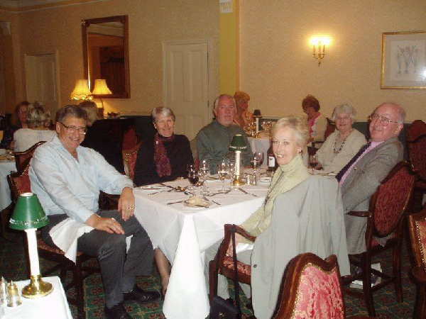
Name: | John Edward Gabbutt-1337¹
Sex: | Male
Father: | Albert Edward Gabbutt-1045 1887-1953
Mother: | Stella May Chivers-3311 1892-1960
Individual Facts
Birth | 13 Aug 1924 | Canada (North America)¹
Departure | abt 1930 (about age 6) | Canada (North America)²
Historical fact | abt 13 Aug 1934 (about age 10) | ³
Military | Apr 1943 (about age 18) | Military Training, Skegness, Lincolnshire, England (United Kingdom)²
Historical data | Jan 2003 (about age 78) | RAF Museum, Hendon, Middlesex County, England (United Kingdom), Europe²
Death | 20 Oct 2016 (age 92) | Northwick Park Hospital, Harrow, Middlesex County, England (United Kingdom), Europe¹
Alt. Name |  | Jack his every-day name-1337⁴
Marriages/Children
1. Jean Marie Shave-6173 1924-2020
Marriage | 17 Jun 1950 (age 25) | St. Mary's Church, Osterley, Middlesex County, England (United Kingdom), Europe¹
Notes
Notes: John Edward Gabbutt-1337
Departure (about 1930): The Departure date was created from info in the recordings
Historical fact (about 13 August 1934): The Antique Postage Stamp Album (printed between Nov 1893 and Dec 1893) was given to Jack on his 10th birthday; he maintained and built the album during his childhood years.
Jack in turn (with his wife, Jean) gave the album to DJ in 1963 as his 13th birthday gift
See the full album and notes at his father's record?
Military (April 1943): Learned that Jack was in the RAF from the tapes; see the Jan 2003 event
Historical data (January 2003): Recordings made of a British NCO photographer, who served in the RAF with 681 and 81 Sqdns in India, Burma, Malaya and Java, 1944-1947
This WWII history page was shared with me in Apr, 2022 by my cousin, Rob Voice
https://www.iwm.org.uk/collections/item/object/80023169
A Transcript follows for each of the 6 recordings
REEL 1
Recollections of background in Canada, Bournemouth, Beckonsfield and Ealing, London, 1924-1943: social circumstances; education; evacuation to Aylesbury, 1939-1940; return to Ealing, 9/1940; question of air raid shelter; blackout; duties as messenger with Air Raid Precaution Unit; effects of war; studying as quantity surveyor; training with 1413 Sqdn, Air Training Corps, 1940-1941; background to enlistment as photographer into RAF. Kitting out and vaccinations at RAF Cardington, 4/1943. Period at Recruit Training Centre, RAF Skegness, 4/1943-5/1943: billets; drill; weapons training; route marches; fatigues; preparing for kit inspections; relationship with recruits and instructor. Period as untrained photographer at RAF Benion, 6/1943-7/1943. Recollections of course at No 1 School of Photography at RAF Farnborough, 7/1943-11/1943: barrack accommodation; shortened nature of course; familiarization with F24 camera and G8 cine-gun camera; film developing process
REEL 2 Continues
film developing process; mobile darkroom; nature of focal plane shutter camera; processing cine-film; photography trade test; colour specialist still graded as 2nd class warrant officer; passing out as aircraftsman 1st class. Period at 24 Operational Training Unit, RAF Honeyborne, 11/1943-7/1944: role of unit; dispersed layout of station; role taking photographs for use in flying crew evasion documents; role servicing F24 camera used with infra-red film during navigational flying tests; role developing cine-gun film recording practice attacks on bombers; visits home; night shifts; reaction to posting overseas. Kitting out at Personnel Despatch Centre, Blackpool, 7/1944. Voyage aboard Strathaird to Bombay, India, 7/1944-8/1944. Recollections of period as photographer with 681 (Photographic Reconnaissance) Sqdn, RAF at RAF Alipore, Calcutta, India and Rangoon, Burma, 8/1944-9/1945: train journey from Bombay; palace accommodation; food rations; kitehawks; role of unit operating from advanced jungle airstrips at Imphal, Monywa, Meiktila and Mingaladon; nature of airfield
REEL 3 Continues
use of F8, F52 and F24 cameras in Spitfires and Mitchells; flights to operate cameras in Mitchell; nature of jungle airstrips used by Spitfires; unit strategic reconnaissance role; periods with advanced force at jungle airstrips including conditions of service and personnel; role loading camera film magazines, setting up camera controls, removing film magazines and transfer to tins; use of Harvard to carry film tins back to Alipore; role of mobile processing unit; conditions of service at jungle airstrips including latrines, tents, scorpion and leech problems and climate; story of Mitchell taking aerial photographs flying under Japanese held bridge; use of Harvard to carry drink to jungle air strips; attachment to US photographic unit experimenting with British cameras and story of visit to communal latrine; opinion of Captain Johnny Rees; promotion to acting sergeant and circumstances of reversion to corporal; view of Spitfire crash on take off from Alipore, 24/12/1944
REEL 4 Continues
circumstances of two Spitfire crashes; routine duties; personal health; situation on move to Rangoon, 1945. Recollections of Operation Zipper invasion of Malaya, 8/1945: role driving vehicles off landing craft; driving course at Bombay; story of birthday celebrations; voyage aboard Liberty ship; question of Japanese surrender; problems on landing on beach. Period at Luala Lumpar airfield, Malaya, 8/1945: redirection of aircraft to Seletar; acting as untrained air traffic controllers; opinion of Japanese POWs on airfield. Recollections of period at RAF Seletar, Singapore, 10/1945-3/1946: nature of stations; makeshift yachts constructed from Japanese seaplane floats and sailing activities; visits to Singapore; reactions to peacetime discipline. Recollections of period at Kemarjordan, Batavia, Java, 4/1946-12/1946: volunteering for detachment duty; political situation; RAF units present; photographic activities; bungalow billet; attacks by Indonesian insurgents and their ambush of RAF leave truck; climate
REEL 5 Continues
photographic duties; recreations; necessity of internal security precautions; story of evading wire across road when driving; visits to Bali; opinion of Dutch colonial rule; relationship with Indonesian civilians; hospitalisation with ear infection; return to Singapore, 12/1946. Recollections of period with 81 Sqdn, RAF at RAF Seletar, Singapore, 12/1946-1/1947: nature of prior strike, 3/1945, including preliminary meeting, refusal to work, attitude of commanding officer, return to work, question of organisers and sympathy for strike; local leave in Penang and story of flight back to Seletar. Voyage aboard Queen of Bermuda to GB, 1/1947-2/1947. Period at RAF Scampton, 3/1947-4/1947: disembarkation leave; photographic duties; demobilisation, 4/1947
REEL 6 Post-war career
qualification and career as quantity surveyor; effects of war service; voluntary work at RAF Museum, Hendon; membership of RAF Association, Photographic Reconnaissance Contact Assoc and Burma Star Assoc; question of official acceptance of squadron crest and badge.
Death (20 October 2016): Learned from their neighbor, Roger Butlin, that Jack had died after a day in hospital for a urinary tract infection

1. The person's data for this event is based on one or more of: 1) FamilySearch entries, 2) Ancestry hints (on RM) or an Ancestry Tree, 3) inferred from the event, or 4) DJs knowledge, Analysis of fact data from a person or picture, their family tree or a source.
2. FamilySearch / Ancestry.com / Inference / Knowledge, All Rights Reserved © 2022 Don Shave.
3. Antique Postage Stamp Album (Date: Abt 1885;).
4. FamilySearch / Ancestry.com / Inference / Knowledge, Research & analysis.

